**Making of Three Dimensional Models of Historical Buildings Present in Mysore City Using SketchUp for Bhuvan**

**Introduction**

Bhuvan gives you an easy way to experience, explore and visualize IRS images over Indian region. ISRO is well known amongst space faring nations for its world-leading reputation in developing new, indigenous and innovative service oriented applications using remote sensing technology. Over the past 2 decades, ISRO has mastered the art of developing these unique applications using various spectral, spatial and temporal resolutions offered by the versatile IRS satellites and these have been successfully institutionalized in many important areas of policy making, natural resources management, disaster support, and enhancing the quality of life across all sections of the society. Now ISRO is adding famous historical buildings present in India in to Bhuvan. So, in this project 3d modeling of famous historical buildings present in mysore city has been carried out using SketchUp.

**Objective:**

* To capture the photographs of Historical buildings present in Mysore city.
* To make 3D models of Historical buildings present in Mysore city Using SketchUp.
* To import SketchUp model in to ArcScene.

**Study Area**

Mysore is located at a north latitude of 12o 17' 45" N and east longitude of 76o 38' 22" E of Karnataka in India.

**Software used:**

* Google Sketchup 8
* Adobe Photoshop CS3
* ArcScene

**Methodology:**

Photographs of all historical buildings present in Mysore have been captured using good quality DSLR camera. Google maps of respective buildings have been imported in to SketchUp to make it as a reference for its exact geographical location and extraction of approximate building boundary. Line has been drawn along the boundary of the building to create single plane surface (Building layout) by using line tool. Push/Pull tool has been used to convert single plane surface in to three dimensional building by specifying approximate building height. Some architectural shapes have been added to building to look like original building. Captured photographs has been imported in to photoshop software to crop them in to required size and also their brightness has been adjusted according to the requirement. Modified images have been imported as texture in to sketchup and they have been pasted on the surface of the building. Some images have became skewed due to the change in the direction of angle of capture so texture pins have been adjusted to make these images in to perfect plane. later texture has been made as a unique texture for future use. Finally completed 3D buildings have been exported to collada(.dae) file extension. Later 3D buildings have been imported in to ArcScene by converting collada(.dae) to multipatch(.shp) format.

**Results:**

Mysore Palace:

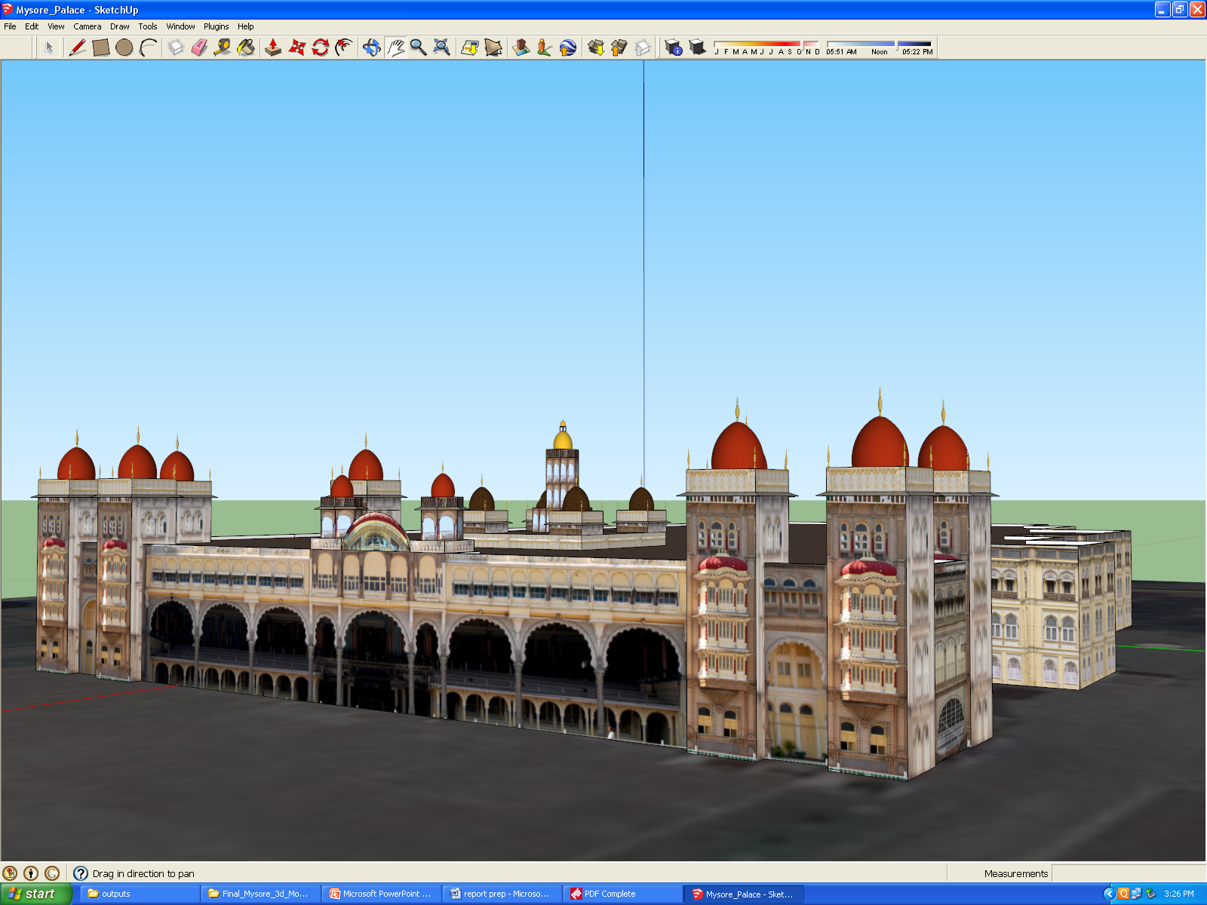

Chamundeshwari Temple:

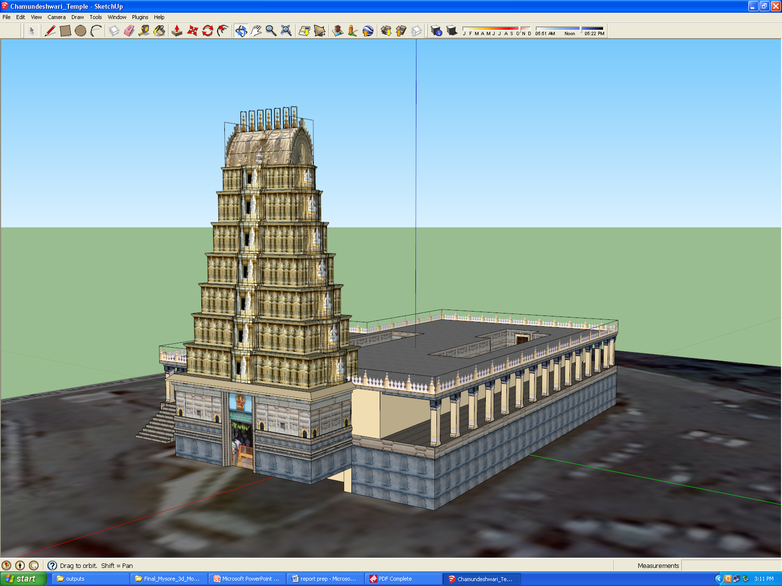

JSS Hospital:

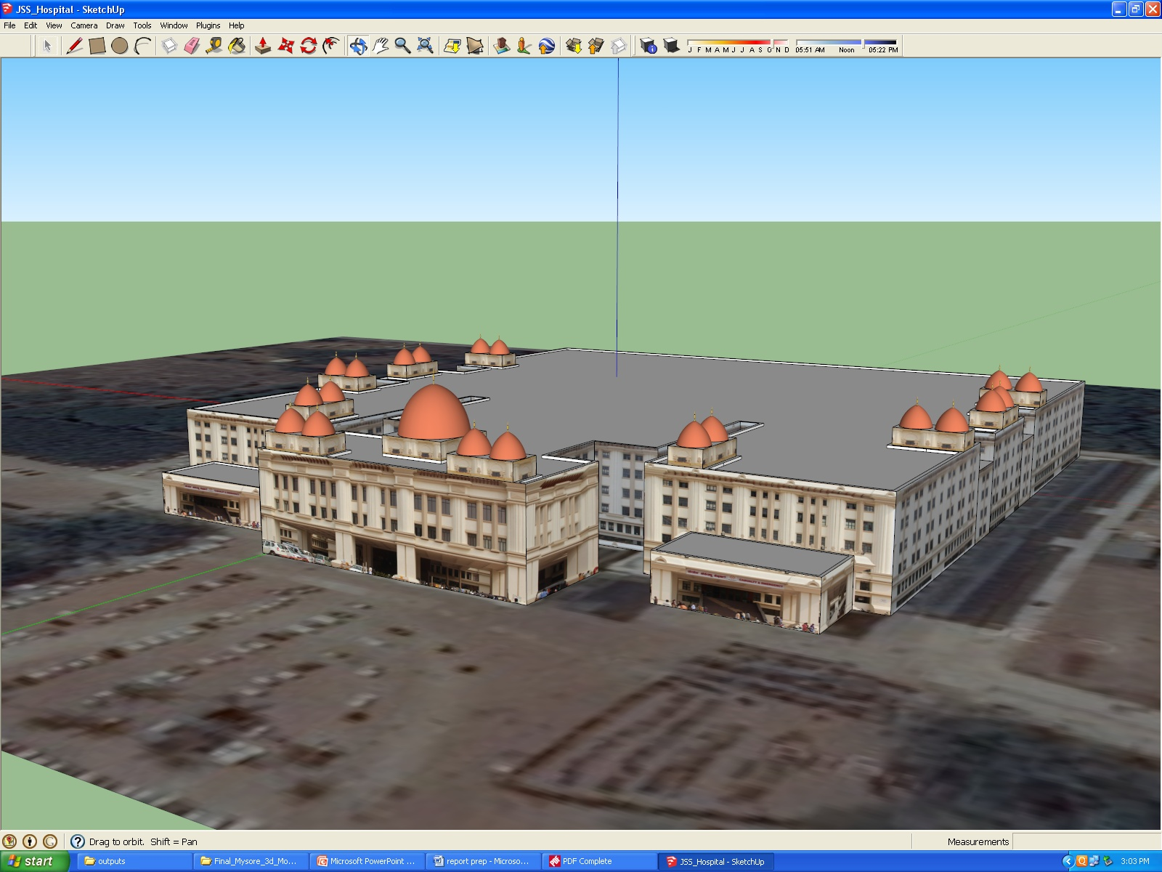

Lalit Mahal Palace:

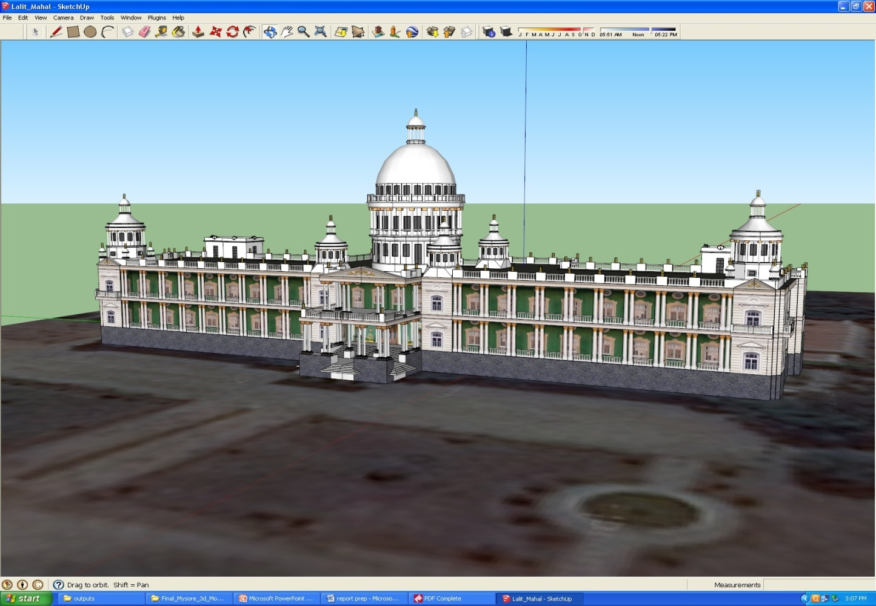

St. Philomenas Church:

